MCAK and Kif18b Stochastic Simulation

MCAK and Kif18b are both human motor proteins. MCAK, a member of the Kin I subfamily of kinesin-related proteins, is well known to destabilize microtubules in human mitotic cells. Instead of being plus or minus end directed, it takes a random walk on the microtubule it is bound to until it reaches one end which it then rapidly depolymerizes. Kif18b, while itself doesn’t depolymerize microtubules, can move MCAK towards the plus end and subsequently cause depolymerization. The goal of this project was to simulate the movement of MCAK and Kif18b at different relative concentrations and initial microtubule length, as well as determining how frequently they interact.

In order to model this behavior, I simulated the position of 200 Kif18b motors and either 4, 50, 100, or 200 MCAK motors over a period of 20 minutes. The simulation assumes that each Kif18b motor is bound to its own microtubule, then MCAK randomly binds to microtubule. At each time step, if a motor is bound to a microtubule, then the rate it moves is based on whether it is alone or at the same position as the other motor. Its position on the microtubule is also important as when it reaches one end it may depolymerize the microtubule if MCAK is present. The position of each motor over time was then graphed for each combination of number of MCAK motors and initial microtubule lengths. The number of times MCAK depolymerized a microtubule itself was tracked, as well as the number of times MCAK and Kif18b associated.

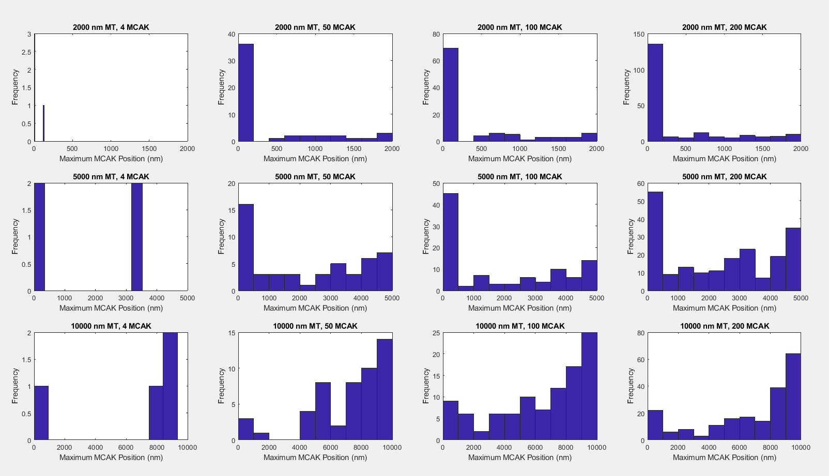

The maximum position of MCAK at the end of each simulation based on initial number of MCAK and microtubule length is shown above. The starting number of MCAK does not appear to have a major effect on the distribution when the initial microtubule length is constant, but increasing lengths of microtubules increases the amount of MCAK that can bind.

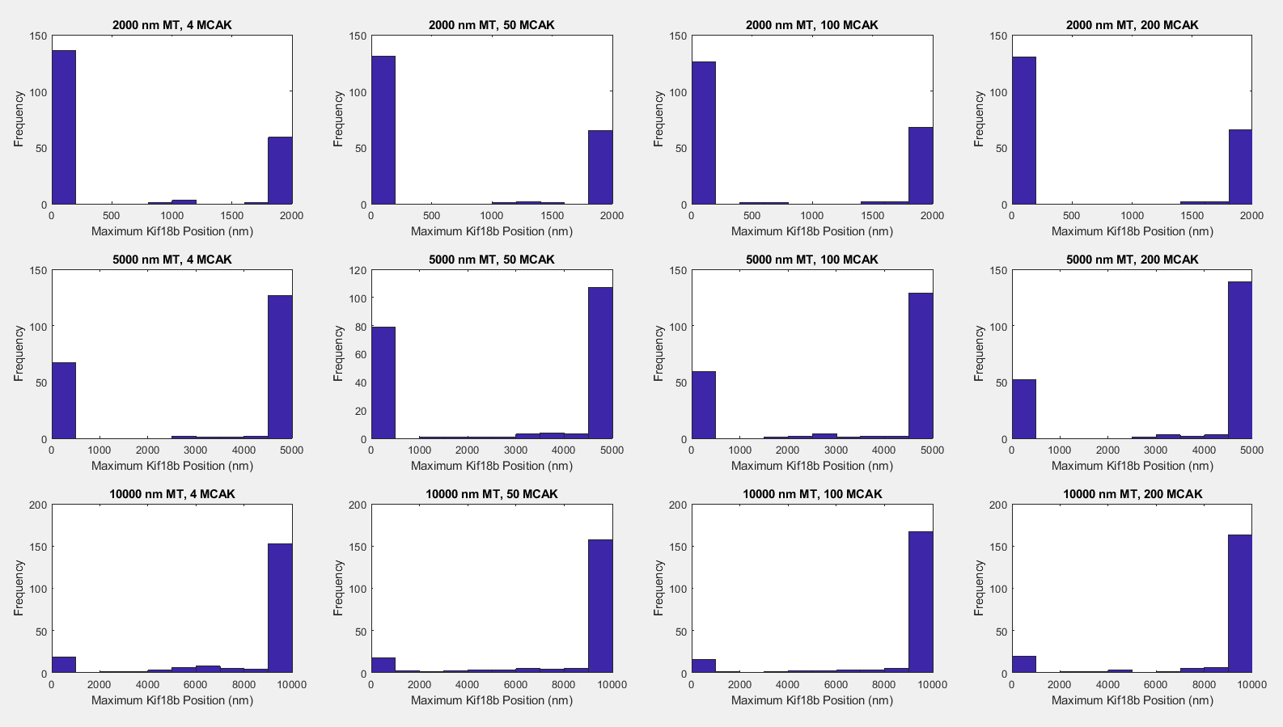

The maximum position of Kif18b is shown above. No matter the microtubule length or amount of MCAK, most Kif18b motors either never bind to a microtubule or make it to the end; increasing lengths of microtubules make it more likely that a Kif18b motor binds.

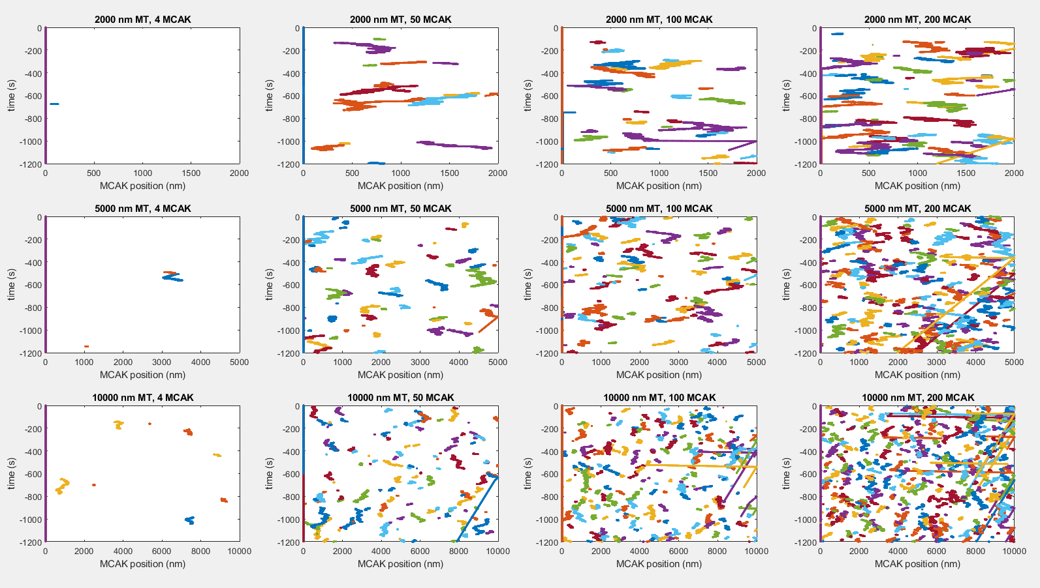

The position of each MCAK over time is shown above. While most MCAKs don’t reach either end of the microtubule or associate with Kif18b before detaching, increasing amounts of MCAK and longer microtubules does increase the chance that Kif18b drags it to the plus end (seen as the almost flat lines starting in the middle of the graph) or makes it to an end by itself, allowing it to depolymerize the microtubule (seen as the diagonal lines starting from the right end of each graph).

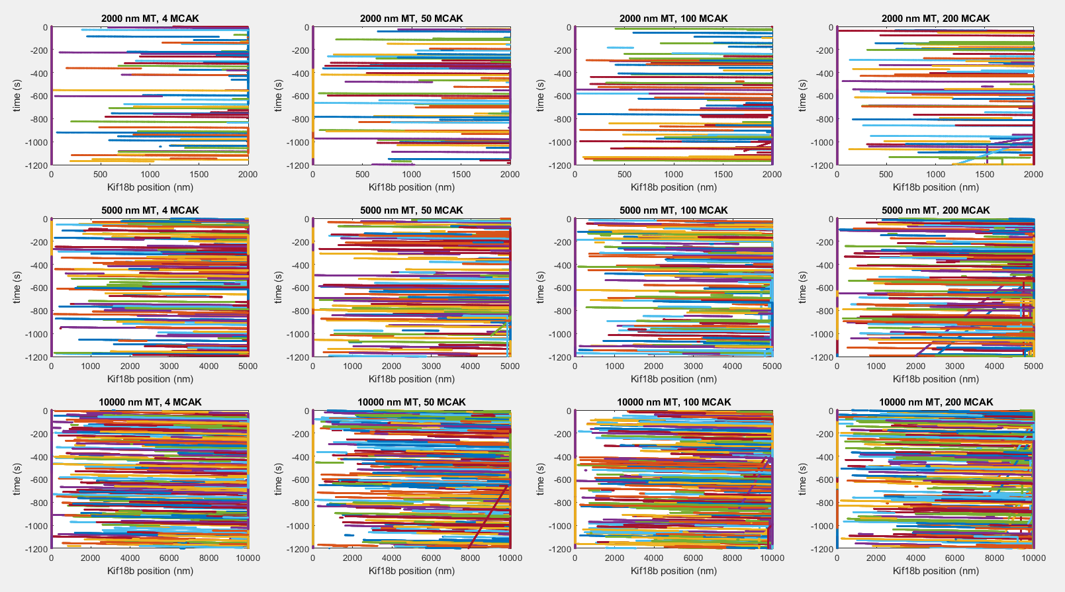

The position of Kif18b over time is shown above. Most Kif18b motors can make it to the end of the microtubule before detaching. Depolymerization events increase with increasing amounts of MCAK.

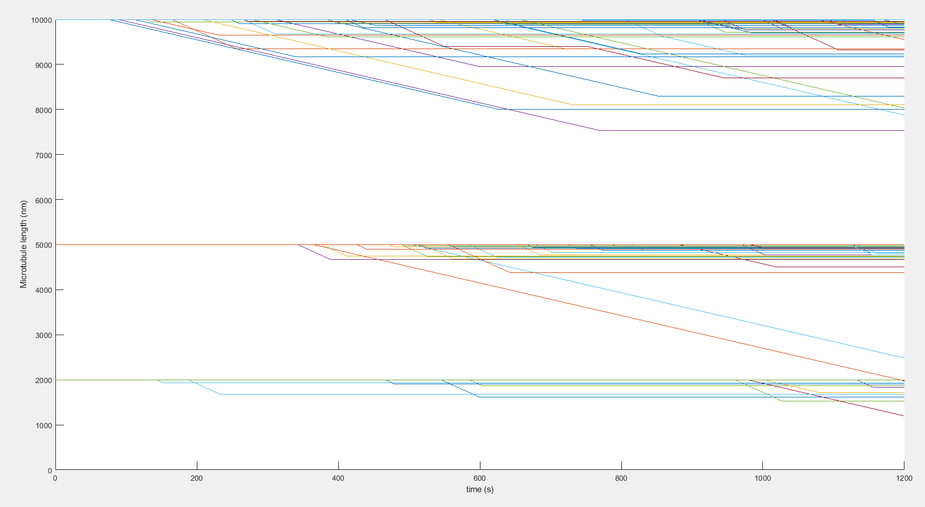

The length of each microtubule over time is shown above. Microtubules that were initially shorter rarely depolymerized, while long microtubules had more frequent depolymerization events. None of the simulated microtubules appear to depolymerize completely.

|  |  |  |  |  |
| --- | --- | --- | --- | --- |
|  | 4 MCAK | 50 MCAK | 100 MCAK | 200 MCAK |
| 2000 nm MT | 0 | 0.6 | 1 | 1.1 |
| 5000 nm MT | 0.2 | 0.5 | 2.4 | 6 |
| 10000 nm MT | 0.1 | 2.1 | 5.9 | 9.7 |

The mean number of times that MCAK and Kif18b associated based on the starting number of MCAK and initial microtubule length is shown above. Each combination was simulated 10 times. Both increasing microtubule length and number of MCAK increased the number of association events.

|  |  |  |  |  |
| --- | --- | --- | --- | --- |
|  | 4 MCAK | 50 MCAK | 100 MCAK | 200 MCAK |
| 2000 nm MT | 0 | 1.6 | 3.2 | 6.5 |
| 5000 nm MT | 0.1 | 1.8 | 2.5 | 6.2 |
| 10000 nm MT | 0 | 1.1 | 1.4 | 4.1 |

The mean number of times that MCAK by itself depolymerized a microtubule based on the starting number of MCAK and initial microtubule length is shown above. Each combination was simulated 10 times. Higher number of MCAK increased the number of times MCAK alone depolymerized microtubules, but increasing initial lengths of microtubules decreased the amount of depolymerization events by MCAK alone.

Parameter Table

|  |  |  |
| --- | --- | --- |
| Variable Name | Description | Value |
| number_kif | Number of Kif18b motors simulated | 200 |
| duration | Length of simulation (seconds) | 20*60 |
| time_step | Length of time that passes every time the simulation loops (seconds) | 0.01 |
| both_depol | Depolymerization rate of a microtubule when both MCAK and Kif18b present (nm/s) | 3.620 |
| motor_off_rate | Rate that motors randomly detach (s-1) | 0.03 |
| v_kif_mean | Mean Kif18b velocity (nm/s) | 349.3 |
| v_kif_sd | Standard deviation of Kif18b velocity (nm/s) | 102.4 |
| v_mcak_mean | Mean MCAK velocity (nm/s) | 0 |
| v_mcak_sd | Standard deviation of MCAK velocity (nm/s) | 380 |
| kif_on | On rate constant for Kif18b attachment | 1 |
| mcak_on | On rate constant for Kif18b attachment | 1 |
| mcak_depol | Depolymerization rate of a microtubule when only MCAK present (nm/s) | 7.13 |
| number_mcak_vector | Number of MCAK motors | [4 50 100 200] |
| initial_MT_Length_vector | Starting length of microtubule (nm) | [2000 5000 10000] |

Overall, the simulation showed that both microtubule length and relative proportions of MCAK and Kif18b affect microtubule depolymerization. As the proportion of MCAK increases, both overall depolymerization and the likelihood of MCAK and Kif18b interacting increases. However, these events were still rare overall. Out of 200 microtubules, the highest average association events was still less than 10 when MCAK was equal with Kif18b, which is unlike real cells as MCAK is typically much lower than Kif18b. Nevertheless, the simulation shows that Kif18b is an important motor protein that influences depolymerization in cells through its interaction with MCAK, despite not being able to depolymerize microtubules itself.